

Documentation

15.05.2022

Contents

Website and interactive timeline 3

Project Information and Plan 3

Team Information 3

Introduction 3

Ways of Realization 4

Block Scheme 4

Work Plan 5

Tasks for completion 6

WEBSITE AND INTERACTIVE TIMELINE

**Project Information**

Our project is made for easy use and education. We created a website with an interactive timeline.

**Team Information**

|  |  |
| --- | --- |
| **№** | **Roles in the team** |
| **1** | Pamela Dimitrakova – Scrum Trainer |
| **2** | Maksim Vasilev – Back End Developer |
| **3** | Mihail Petrov – Back End Developer |
| **4** | Hristiyan Petrov – Quality Assurance |

**Introduction**

|  |  |
| --- | --- |
| **№** | **Introduction** |
| **1** | What is the product?  Our project is a recreation of the card game bOOleO, where you need to use boolean logic to create a pyramid faster than your opponent. |
| **2** | How can you access it?  You can read about our collaborative work on GitHub and access the files in our project’s repository. |
| **3** | What about communication?  We communicated through Teams due to its helpful functions like screen sharing and text channels. The team was well connected and the work was efficient. |
| **4** | What programs were used?  Programs we used consisted of GitHub for file management and collaborative work, Visual Studio Code for code editing, MS Teams for communication, MS PowerPoint for our Presentation, MS Word for the documentation and Figma for our design. |

**Ways of Realization**

|  |  |
| --- | --- |
| **№** | **How did we do it?** |
| **1** | Task Distribution  The Tasks were distributed based on the skillset of everyone. We also notified each other when changes were made to the project so everyone was always up to date. This way our team was as productive as possible. |
| **2** | Task Completion  Every day at around 19 p.m. we held a meeting to track the development of the project and help each other progress further. It also helped us resolve issues and share ideas. |
| **3** | Deadlines  In these meeting we also discussed time management, how specific parts were coming along, what everyone had done in their specified time and what things should be completed in the near future. |

**Block Scheme**

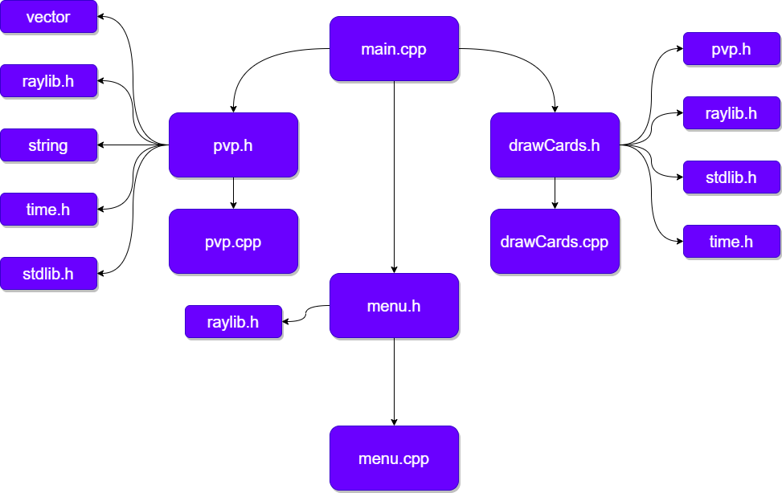

WORK PLAN

**Tasks for Completion**

|  |  |
| --- | --- |
| **№** | **Task Breakdown** |
| **1** | Set up Raylib  The library was set up by the QA and the back-end developers. Having it set up permitted further with graphics and textures. |
| **2** | Design game textures  The card textures were designed by the QA in Figma. The design is strongly influenced by the card game bOOleO. |
| **3** | Load initial binary cards  The initial binary cards were loaded by the back-end developers. Initial binary cards are loaded with a function that is based on a random number that flips them. |
| **4** | Implement card deck and drawing function  The drawing function and card deck were implemented by the back-end developers. The drawing function displays a random texture from a vector that contains all the cards. |
| **5** | Add basic menu  The menu was implemented by the back-end developers. At the time it represented only some text which could help us which game mode to select. |
| **6** | Add Collision for card placement  For each card placeholder in then background a small collision rectangle was added by the back-end developers. These rectangles serve to identify the position on which the cards will stay. |
| **7** | Add drag function  The drag function was added by the back-end developers. With the help of the collision rectangles the players could move and place cards on different spots of the premade pyramids. |
| **8** | Dealing function  The dealing function was added by the back-end developers. It allowed with a single click of the card deck to display both player’s initial card decks. |
| **9** | Update menu  The menu was redesigned by the QA and set to show on start of the game. |
| **10** | Documentation  The documentation was created by the designer and our scrum-trainer using Word to summarise the website and explain its functions. |
| **11** | Presentation  The presentation was created by the designer and our scrum-trainer to explain the concept of the application, specify the used programs and establish the roles of the teams. |